**Week 2: SL4J Logging exercises**

**Exercise 1: Logging Error Messages and Warning Levels**

**Task:** Write a Java application that demonstrates logging error messages and warning levels

using SLF4J.

**I am not adding the dependencies given in the handbook as the dependencies are already integrated in my IntelliJ IDE**

**LoggingExample.java**

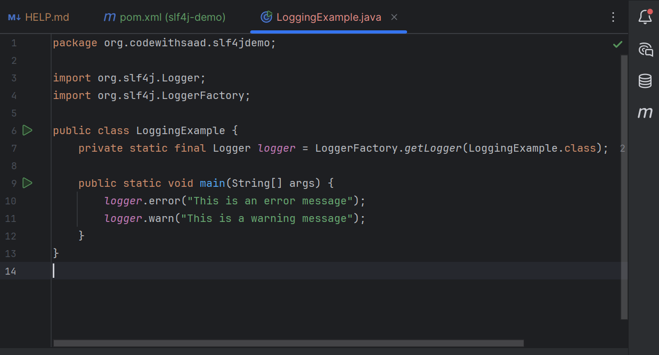

**OUTPUT:**

